Project Title: SOLAR SYSTEM
Name of the Students: 1. Om Jangam
Name of the Guide: Mrs. Manjiree Otari
Objective: To create an engaging, visually appealing, and interactive representation of the solar system, utilizing OpenGL's 3D rendering tools for understanding the structure and behavior of our solar system.
Abstract of project work:  The "Solar System" project is an interactive 3D simulation of the Solar System, built with OpenGL and libraries like GLEW, GLUT/GLFW, and GLM. It visualizes planetary orbits, rotations, and scales realistically, modeling the Sun, planets, and moons with textures, lighting, and shading. The simulation includes realistic orbital mechanics, rotation dynamics, and lighting effects to mimic sunlight. Key features include user controls for zooming, rotating views, and toggling display options, making it an educational tool for exploring planetary science and showcasing OpenGL’s real-time rendering capabilities. | Architecture Diagram:
Algorithmic Approach Used:  So we propose a deep learning approach to classify CWL levels based on EEG signals. The input to the system is raw EEG data extracted from the STEW dataset. A three step approach is proposed for obtaining the output. First step includes data preprocessing for removing noise from the data using Artifact Subspace Reconstruction (ASR). This project compares the results of Convolutional Neural Networks (CNN), Gated Recurrent Unit (GRU) and composite model of CNN extracts features from the preprocessed EEG data which are then used by GRU algorithm for classification | Applications:  • Visualize a solar farm with panels arranged in rows.  • Simulate panel rotations based on sun position.  • Display real-time power generation, efficiency, and sunlight exposure.  • Simulate solar panel performance based on angle, sunlight intensity, and environmental factors.  • Use OpenGL to render the panels and lighting effects.  • Provide sliders for users to adjust parameters and see real-time performance updates.  • Plot graphs showing power generation vs. panel angle and weather conditions.  Advantages & Limitations:  The OpenGL-based solar system project provides real-time interactive 3D visualization of solar power systems, allowing users to explore solar panel performance, energy generation, and cognitive workload monitoring, making it a valuable educational and training tool. However, it faces challenges in accurately modeling complex real-world factors such as solar energy dynamics, environmental conditions, and cognitive workload,. Additionally, the project can be computationally demanding, potentially causing performance issues on lower-end hardware, and may lack the depth and real-world integration needed for large-scale solar farm management or operational control. | Results:  .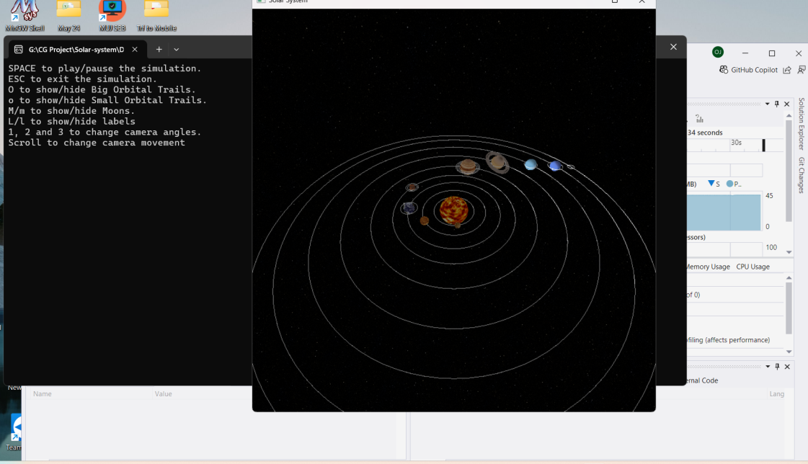

Conclusion: The Solar System simulation project showcases the capabilities of OpenGL for real-time rendering and interactive graphics. This application provides a valuable educational experience by simulating complex astronomical phenomena in an intuitive, visually engaging manner. The project also highlights how OpenGL’s graphical power can be effectively utilized in developing applications that combine science and visualization. Future enhancements could integrate additional features, such as asteroids, comets, and real-time astronomical data.

